Suraj Singh (Superset ID: 7808362)
WEEK 5

ReactJS Hands-on Assessment

Task 1: Create React App 'myfirstreact'
Objective: Create a simple React app that prints a heading.

Steps:
1. Install Node.js and npm from: https://nodejs.org/en/download/
2. Open VS Code Terminal and run:
npx create-react-app myfirstreact
cd myfirstreact
code .
3. Open src/App.js and replace content with:

import React from 'react';

function App() {
return (
<div>
<h1>Welcome to the first session of React</h1>
</div>
);
}

export default App;

4. Run the application:
npm start

OUTPUT:
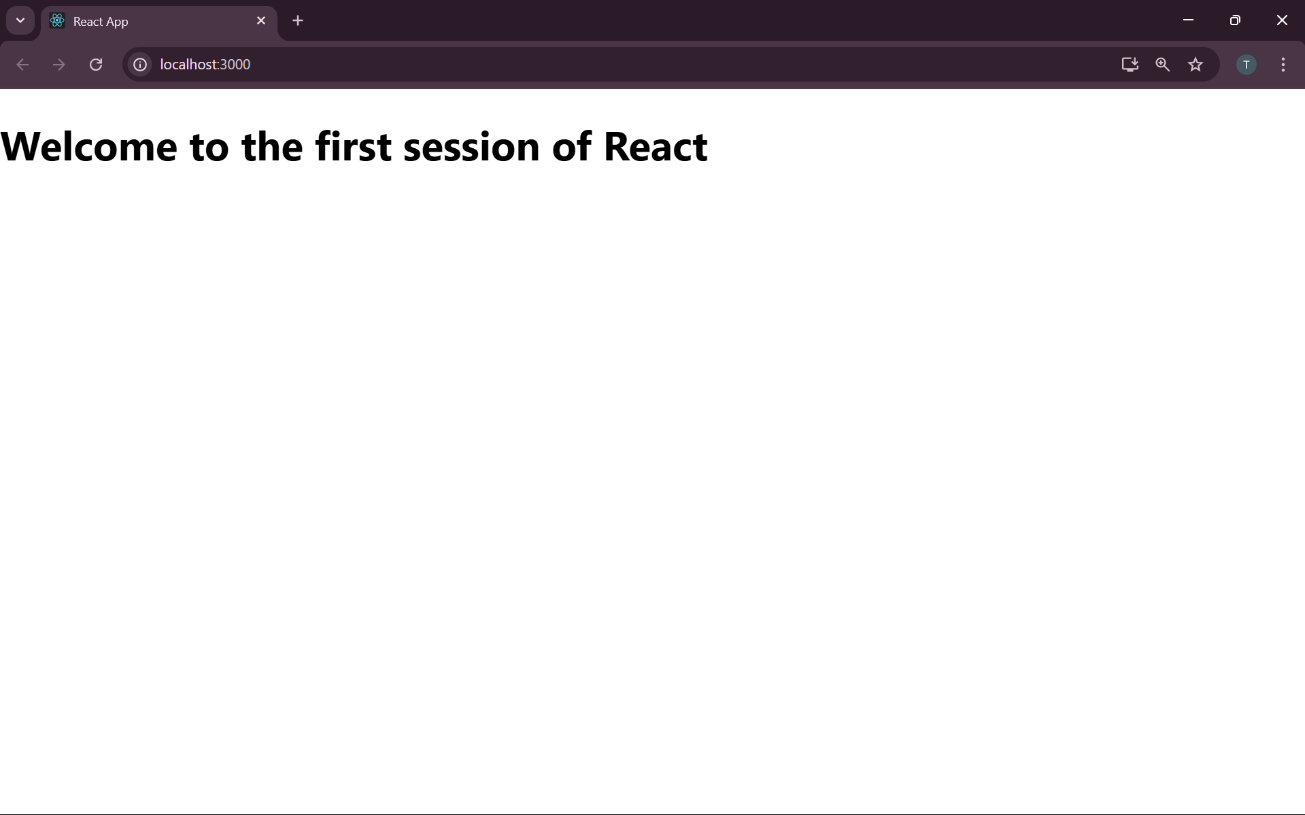

Task 2: StudentApp with Class Components
Objective: Display Home, About, and Contact pages using class components.

Steps:
1. Create project:
npx create-react-app studentapp
cd studentapp
code .
2. Under src, create folder Components and files Home.js, About.js, Contact.js

Example: Home.js

import React from 'react';

class Home extends React.Component {
render() {
return <h2>Welcome to the Home page of Student Management Portal</h2>;
}
}

export default Home;

3. Repeat above for About.js and Contact.js with respective messages.

4. Update App.js:

import React from 'react';
import Home from './Components/Home';
import About from './Components/About';
import Contact from './Components/Contact';

function App() {
return (
<div>
<Home />
<About />
<Contact />
</div>
);
}

export default App;

5. Run the application:
npm start

OUTPUT
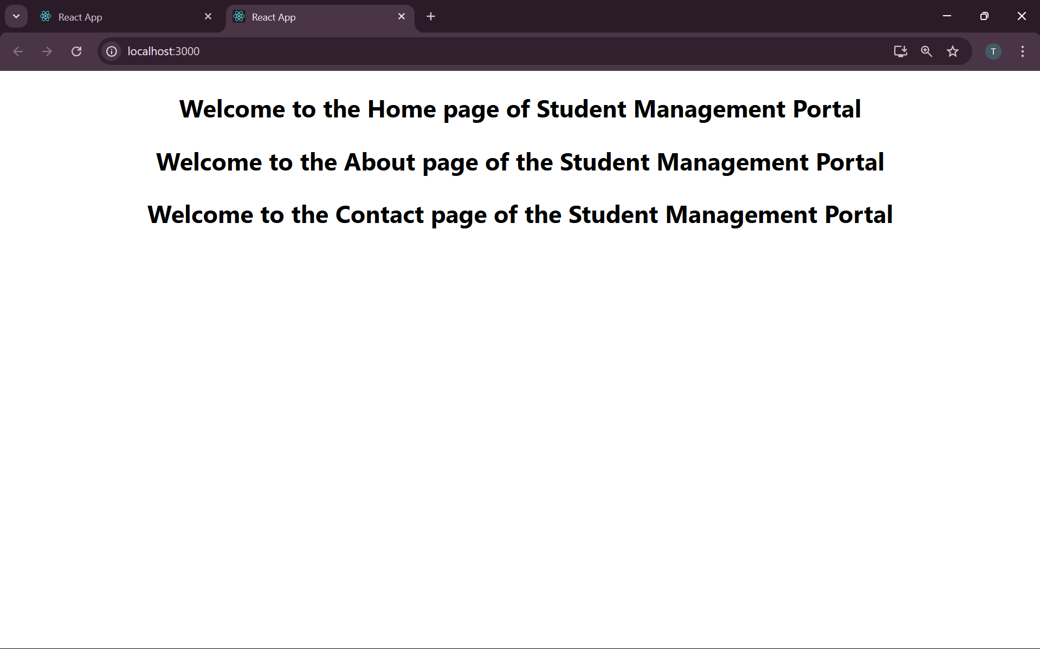

Task 3: Score Calculator App
Objective: Create a function component to calculate and display average score.

Steps:
1. Create project:
npx create-react-app scorecalculatorapp
cd scorecalculatorapp
code .
2. Create src/Components/CalculateScore.js

import React from 'react';
import '../Stylesheets/mystyle.css';

function CalculateScore() {
const name = "Riya";
const school = "St. Xavier's";
const total = 470;
const goal = 500;
const average = (total / goal) * 100;

return (
<div className="score-card">
<h2>Student Score Calculator</h2>
<p><strong>Name:</strong> {name}</p>
<p><strong>School:</strong> {school}</p>
<p><strong>Total:</strong> {total}</p>
<p><strong>Goal:</strong> {goal}</p>
<p><strong>Average:</strong> {average.toFixed(2)}%</p>
</div>
);
}

export default CalculateScore;

3. Create mystyle.css in Stylesheets folder:

.score-card {
width: 400px;
margin: 30px auto;
padding: 20px;
border: 2px solid #3498db;
border-radius: 10px;
box-shadow: 0px 4px 8px rgba(0,0,0,0.1);
font-family: Arial;
}

4. Import and use component in App.js
5. Run the application:
npm start

OUTPUT:
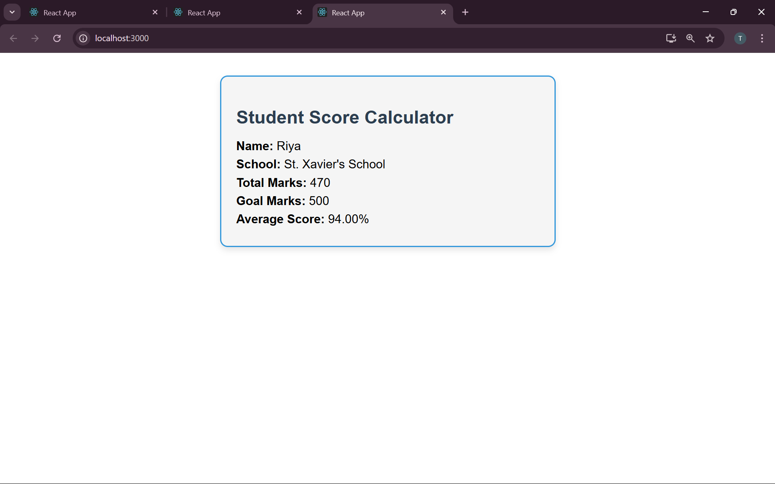

Task 4: BlogApp with Lifecycle Methods
Objective: Use componentDidMount() to fetch posts and componentDidCatch() to handle errors.

Steps:
1. Create project:
npx create-react-app blogapp
cd blogapp
code .

2. Create Post.js:

import React from 'react';

class Post extends React.Component {
render() {
return (
<div>
<h3>{this.props.title}</h3>
<p>{this.props.body}</p>
</div>
);
}
}

export default Post;

3. Create Posts.js:

import React from 'react';
import Post from './Post';

class Posts extends React.Component {
constructor() {
super();
this.state = { posts: [], hasError: false };
}

componentDidMount() {
this.loadPosts();
}

loadPosts() {
fetch('https://jsonplaceholder.typicode.com/posts')
.then(response => response.json())
.then(data => this.setState({ posts: data }))
.catch(() => this.setState({ hasError: true }));
}

componentDidCatch() {
alert("An error occurred");
}

render() {
if (this.state.hasError) return <h2>Error loading posts</h2>;
return (
<div>
<h1>Blog Posts</h1>
{this.state.posts.slice(0, 10).map(post => (
<Post key={post.id} title={post.title} body={post.body} />
))}
</div>
);
}
}

export default Posts;

4. Update App.js to import and use <Posts />
5. Run the application:
npm start

OUTPUT:
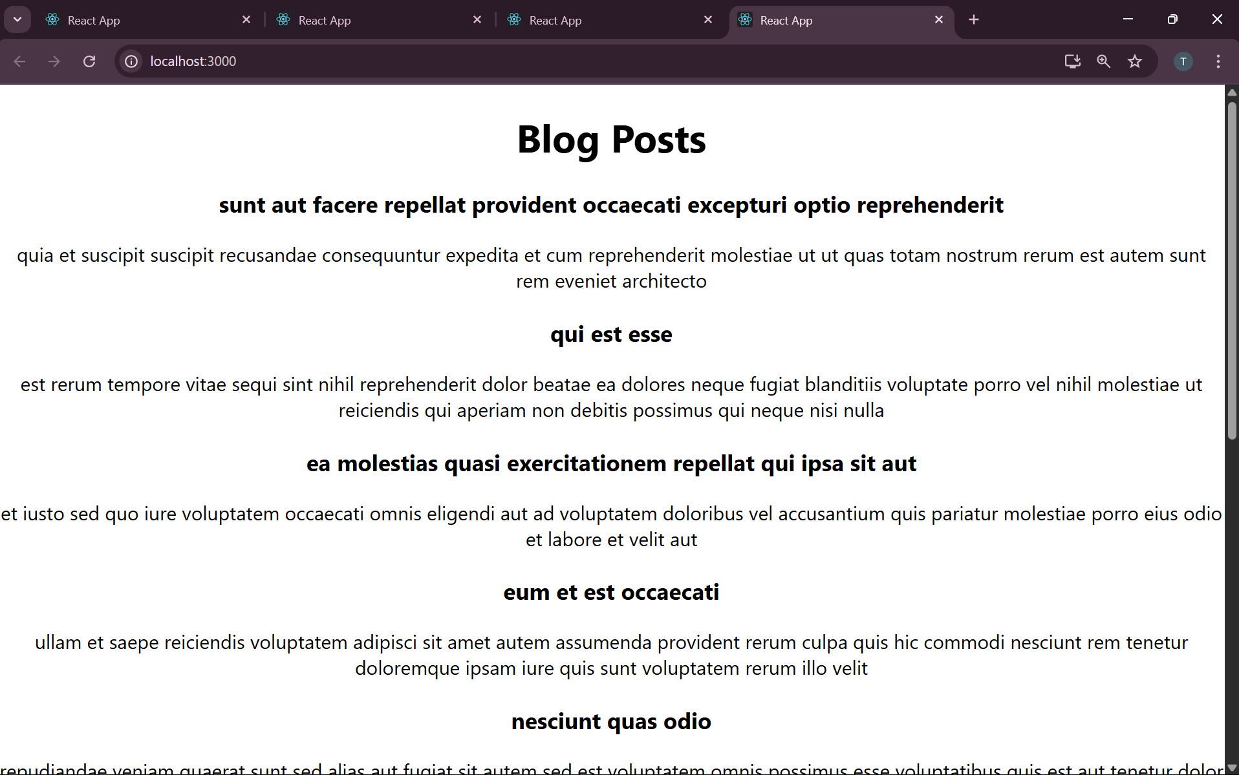

Task 5: Style Cohort Cards using CSS Modules
Objective: Style cards using CSS Modules and inline styles.

Steps:
1. Create project:
npx create-react-app cohortstracker
cd cohortstracker
code .

2. Create src/components/CohortDetails.js

import React from 'react';
import styles from './CohortDetails.module.css';

function CohortDetails({ cohort }) {
const titleStyle = { color: cohort.status.toLowerCase() === 'ongoing' ? 'green' : 'blue' };

return (
<div className={styles.box}>
<h3 style={titleStyle}>{cohort.name}</h3>
<dl>
<dt>Started On</dt><dd>{cohort.started}</dd>
<dt>Current Status</dt><dd>{cohort.status}</dd>
<dt>Coach</dt><dd>{cohort.coach}</dd>
<dt>Trainer</dt><dd>{cohort.trainer}</dd>
</dl>
</div>
);
}

export default CohortDetails;

3. Create CohortDetails.module.css:

.box {
width: 300px;
display: inline-block;
margin: 10px;
padding: 10px 20px;
border: 1px solid black;
border-radius: 10px;
}

dt {
font-weight: 500;
}

4. Add multiple cohort data in App.js and render using map and <CohortDetails />
5. Run the application:
npm start

OUTPUT:
